GE Free New Zealand
In Food And Environment Inc.

PO Box 13402, Wellington, NZ
Tel: 027 479 4195
13 June 2023
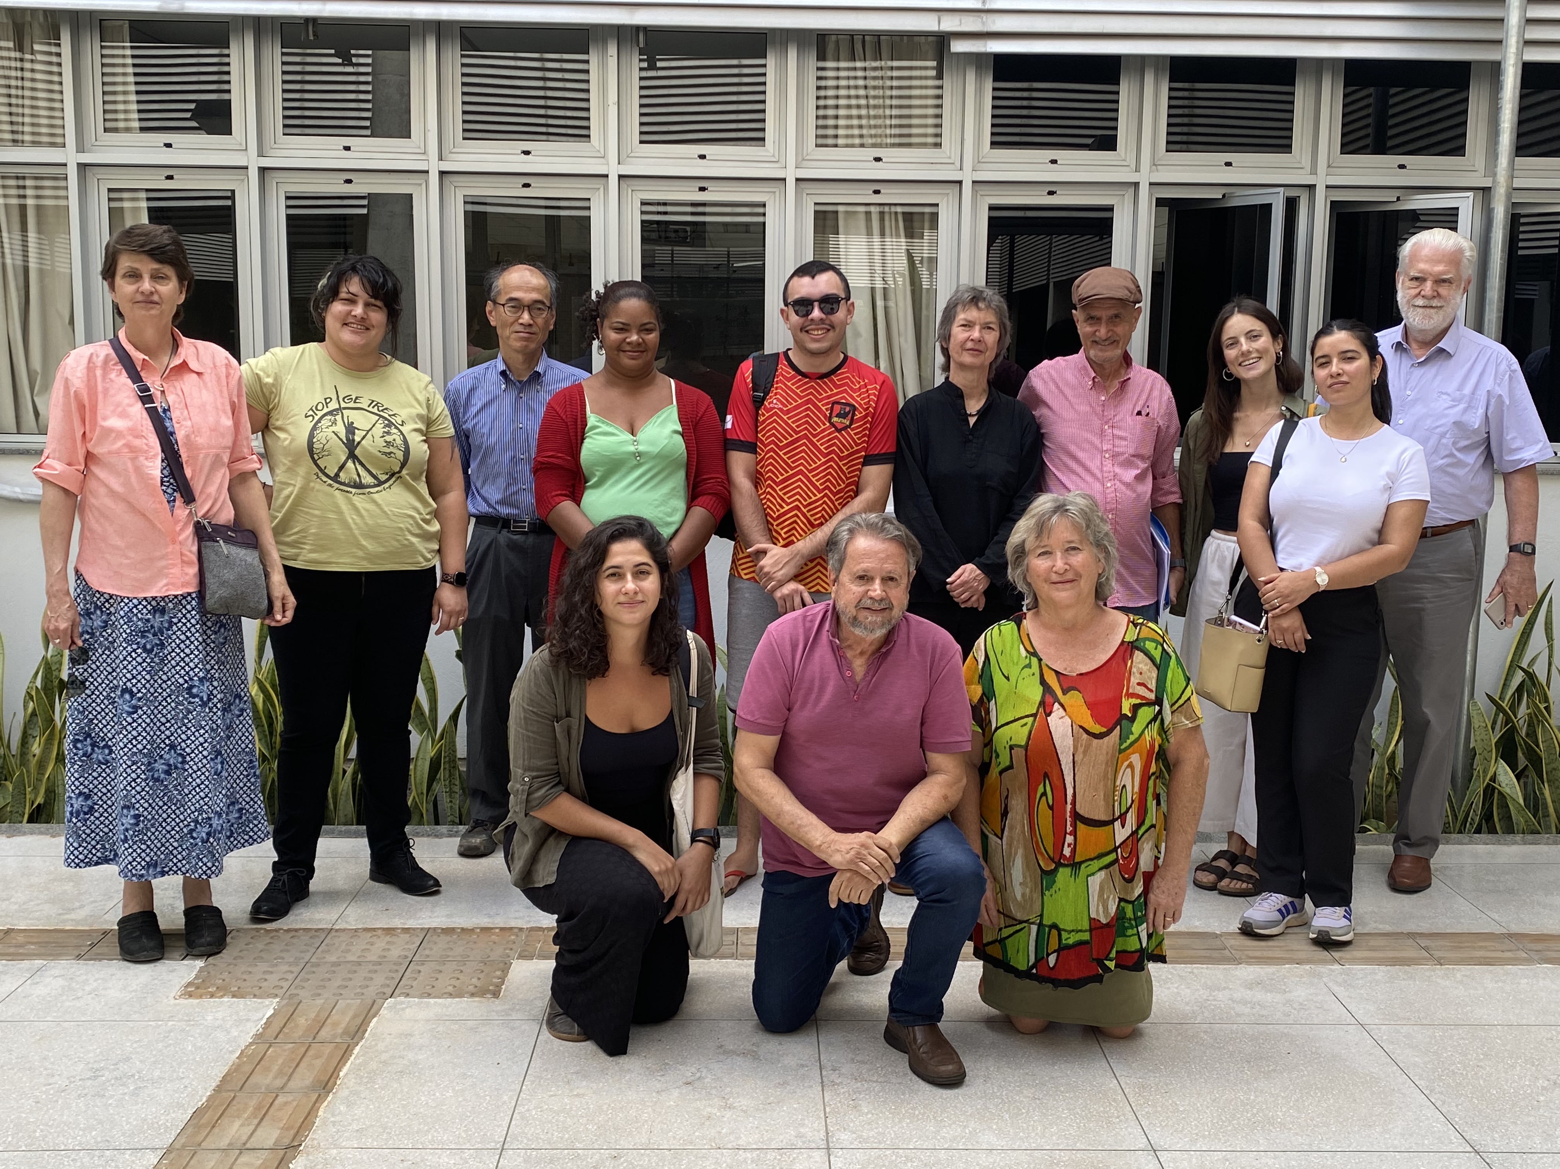

An International Delegation representing USA, Canada, Japan, Europe, New Zealand, Brazil, Argentina and Chile, organised by Global Justice Ecology Project (GJEP) went to Brazil on a investigative tour supported by the Campaign to Stop GE Trees.

We visited the indigenous, landless workers and Quilombola peoples in Bahia, Espirito Santo and Mato Grosso. The region was dotted with small agroecological farms, organically managed and rich in diversity. There were plants of manioc, acerola, pineapple, watermelon, mango, greens, sugar cane, coffee and rubber trees. The birds, bees and butterflies were seen in abundance.
An MST (landless workers) farm grew the largest organic rice production in Brazil that exported around the World. A thriving community fighting to live as their ancestors protecting nature and giving hope to their children.

All this is under threat as they have no title to their lands. Big corporations are cutting down the Atlantic and Amazon forests and creeping into the Cerrado where rivers and wetlands are being polluted by pesticides from the vast Eucalyptus plantations.
In 2015 and 2018 the Government in Brazil approved the plantation of GE Eucalyptus. New Zealand Rubicon’s, Horizon2, (later ArborGen) premises developed and exported over 500,000 GE seedlings and cell cultures to the US and Brazil.

However, whilst international forestry corporations are raping and pillaging the Brazilian land for paper and bio fuels, we heard of the loss of the indigenous peoples sovereignty. Their sacred rivers and forests had been decimated by 16 million hectares of silent Eucalyptus Tree plantations. Wetlands had dried up, the constant aerial spraying of pesticides is polluting their water supply, and the spray drift is killing their food and trees. Animals had disappeared and fish had died from the pollution. Their children were suffering from ill health. With no title to their lands they are being slowly killed off, drifting away to work in slave labour conditions up to 16 hours a day for the big corporations.

Suzano is building the biggest cellulose pulp and paper mill in the World covering 400 hectares, in Mato Grosso do Sul. The plantations that are needed to supply this mill are being grown on contested indigenous land. These thirsty, incendiary Eucalyptus devastate the ecosystem and increase pesticide aerial applications and kill the native insects and birds.

When driving through Mato Grosso do Sul all that you could see was Eucalyptus. We met with the Ofaié indigenous peoples. In the 1900’s they lived along the Piranhas River, with a population in the thousands. However, a big energy corporation got permission to build a hydroelectric dam and they were moved off their indigenous lands to a small area of 450 hectares, a similar size as Suzano’s Mill. They are nowhere near the river and surrounded by 2 million hectares of Eucalyptus Plantations. They are now a small community as many have moved to find work in towns.

Many in Brazil’s Federal Government are troubled over these dire conditions. Our delegation met with Ministry’s of Agriculture, the Environment, Original Peoples to express our concerns over the destruction and plight of the peoples we spoke with, as well as the added dangers of planting GE Eucalyptus. We heard that they are trying to redress this horrific treatment of the indigenous, landless and Quilombola peoples by giving title to their lands.

However, the Congress has a majority of members who have vested interests and own properties or investments in these areas. Their vote is continually blocking any legislation (PL490) and not allowing these lands to be reclaimed as indigenous. The situation is dire for these peoples.

We must find ways to support organisations like FASE in their ethical and moral struggle to stop the privatisation of life. We must support the call for a moratorium of GE trees that indigenous, Landless and Quilombola peoples of Brazil are calling for.

Claire Bleakley
027 348 6731
13 June 2023

